

**SIMATS SCHOOL OF ENGINEERING**

**SAVEETHA INSTITUTE OF MEDICAL AND TECHNICAL SCIENCES**

**CHENNAI-602105**

**Online hotel room booking System**

**A CAPSTONE PROJECT REPORT**

*Submitted in the partial fulfillment for the award of the degree of*

**BACHELOR OF ENGINEERING**

**IN**

**INFORMATION TECHNOLOGY**

**Submitted by**

**(192211299)**

**P. Ganesh (192211219)**

**Ch. Bhanu Prakash (192211495)**

**Siva Prasad (192210398)**

**Under the Supervision of**

**Rajagopal K**

**October 2024**

**DECLARATION**

We, **Battina Sai, Ganesh, Bhanu Prakash, Siva Prasad**, students of **Bachelor of Engineering in Information Technology**, Department of Computer Science and Engineering, Saveetha Institute of Medical and Technical Sciences, Saveetha University, Chennai, hereby declare that the work presented in this Capstone Project Work entitled **Hotel Room Reservation System** is the outcome of our own bonafide work and is correct to the best of our knowledge and this work has been undertaken taking care of Engineering Ethics.

(Battina Sai 192211299)

(Ganesh 192211219)

(Bhanu Prakash 192211495)

(Siva Prasad 192210398)

Date:

Place:Chennai

**CERTIFICATE**

This is to certify that the project entitled **“Hotel Room Booking System”** submitted by **Battina Sai, Ganesh, Bhanu Prakash, Siva Prasad** has been carried out under my supervision. The project has been submitted as per the requirements in the current semester of B. Tech Information Technology.

Teacher-in-charge

Rajagopal K

**Table of Contents**

|  |  |
| --- | --- |
| **S.NO** | **TOPICS** |
| 1 | **Abstract** |
| 2 | **Introduction** |
| 3 | **Project Description** |
| 4 | **Problem Description** |
| 5 | **Tool Description** |
| 6 | **Operations** |
| 7 | **Approach / Module Description / Functionalities** |
| 8 | **Implementation** |
| 9 | **Output** |
| 10 | **Conclusion**    **References** |

### Abstract

An online hotel room booking system provides a convenient platform for users to search and reserve hotel rooms effortlessly. Through this system, users can register, browse available rooms based on their destination, dates, and number of guests, and complete bookings with a secure payment gateway. The system ensures that users can manage their reservations, view booking history, and modify or cancel bookings within a specified time frame, offering a seamless experience from start to finish.

To ensure the security and reliability of transactions, the platform incorporates secure payment gateways that support various payment methods, including credit/debit cards, net banking, and digital wallets. Once the booking process is complete, users receive e-tickets via email and SMS, providing immediate access to their travel details. The system also offers options for booking cancellation and refund processing, adhering to the bus operator's policies and ensuring a flexible experience for users. A robust admin panel allows bus operators to manage schedules, seat layouts, and pricing efficiently, as well as access detailed reports on bookings and revenue.

For administrators, the system offers powerful management tools to oversee room availability, pricing, and booking details. Administrators can update static information such as hotel policies, room descriptions, and contact information, ensuring that the website remains up-to-date and informative. Additionally, they can handle bookings, manage customer feedback, and ensure smooth operations through an admin panel. The platform is fully responsive, allowing users to access the system from any device, providing an optimal experience on both desktop and mobile. Integrated features like confirmation emails, reviews, and local travel guides enhance the user experience, making the booking process not only efficient but also informative and user-friendly.

**Introduction:**

An online hotel room booking system is a web-based platform designed to streamline the process of finding and reserving accommodations in hotels, resorts, or other lodging facilities. It provides a convenient way for travelers to browse available rooms, compare prices, and secure bookings without needing to visit the hotel physically or call for reservations. With the increasing demand for travel and accommodation, such systems have become an essential tool for both users and hotel management. The platform can be accessed anytime, offering users the flexibility to make bookings at their convenience, which significantly enhances customer satisfaction. Moreover, it is equipped with features like real-time room availability, secure payment processing, and automated booking confirmations.

At its core, the system allows users to search for hotels by location, dates, and the number of guests, ensuring they can find the most suitable accommodation for their needs. Once a user enters the required details, the system presents a list of available rooms, often accompanied by detailed information about the hotel, room types, amenities, prices, and cancellation policies. The user can also view photos of the rooms and hotel facilities to make an informed decision. The booking process involves selecting a room, filling in personal details, and proceeding with payment via a secure payment gateway integrated within the platform. Upon successful booking, users receive a confirmation email with details of their stay, and in some cases, an e-ticket or voucher to present upon arrival at the hotel.

For administrators and hotel managers, an online booking system provides extensive control over room availability and pricing. They can easily manage room inventory, adjust prices based on demand, and update room descriptions and hotel information through an intuitive admin panel. This dynamic management capability ensures that the hotel stays competitive while offering accurate and up-to-date information to potential guests. Administrators can also oversee customer bookings, handle modifications or cancellations, and generate reports on bookings, revenue, and occupancy rates. This centralized management feature streamlines hotel operations and reduces the risk of overbooking or double-booking rooms, thereby improving operational efficiency.

Furthermore, an online hotel booking system typically includes a feedback mechanism, where guests can leave reviews or ratings after their stay. This feature is valuable for both future travelers and hotel management. Positive reviews can boost a hotel's reputation, while constructive feedback helps management identify areas for improvement. By gathering user feedback, hotels can tailor their services to better meet customer expectations, leading to higher guest satisfaction and loyalty. Additionally, the platform can include promotional features such as discounts, special packages, or loyalty programs to encourage repeat bookings and attract new customers.

The system is designed to be fully responsive, allowing users to access it from any device, including desktops, tablets, and smartphones. This ensures that users can make bookings on the go, whether they are at home, at work, or traveling. The user-friendly interface, combined with a seamless booking process, enhances the overall user experience. With secure payment processing and the ability to modify or cancel bookings up to a specific date, an online hotel room booking system not only simplifies the booking experience but also provides peace of mind for users. In a fast-paced, tech-driven world, such platforms are invaluable for both travelers seeking convenience and hotels aiming to maximize their occupancy and revenue

**Project Description**

The online bus booking system is a web-based platform designed to facilitate the process of booking bus tickets for travelers and managing bookings for bus operators. The system is built to provide a seamless and efficient user experience, allowing users to book tickets from the comfort of their homes or on-the-go via their mobile devices.

Our mission is to revolutionize the bus travel experience by leveraging technology to provide a seamless, efficient, and user-friendly online booking platform. We aim to empower travelers with the convenience of booking tickets anytime, anywhere, and to enhance the operational efficiency of bus operators through innovative solutions. By prioritizing customer satisfaction, security, and ease of use, we strive to become the leading platform in the bus transportation industry, fostering a more connected and accessible world for everyone.

**Accuracy:** Accuracy is crucial in our online bus booking system, providing users with reliable, real-time information on bus schedules, seat availability, and pricing. Our platform ensures data validation and secure transactions to maintain high standards of trustworthiness. By prioritizing accuracy, we aim to deliver a dependable and seamless booking experience.

**Convenience:** Our online bus booking system prioritizes convenience, allowing users to effortlessly search for, select, and book bus tickets from any device, anywhere, at any time.

**Security:** Security is a top priority in our online bus booking system, ensuring that users' personal and financial information is protected at all times. We employ advanced encryption protocols and secure payment gateways to safeguard data during transactions. Regular security audits and updates are conducted to maintain a robust defense against potential threats, providing users with a safe and trustworthy booking experience.

**Problem Description**

**Real-time Data Accuracy and Availability:**

Our **online hotel room booking system** ensures real-time data accuracy and availability, offering users the most up-to-date information on room availability, pricing, and hotel details. By integrating real-time data across the platform, users can make quick and informed decisions when selecting their desired accommodations. Continuous monitoring and regular updates ensure that the information provided is always current, enhancing the platform’s reliability and improving the overall user experience.

**Data Source Reliability:**

Data source reliability is critical to the success of our online hotel booking system, ensuring that all hotel information, including room availability, pricing, and policies, is accurate and up-to-date. We work closely with hotel operators, continuously verifying and updating the data to minimize errors and discrepancies. This commitment to reliable information guarantees a smooth and trustworthy booking experience for users, reinforcing confidence in the platform.

**Security Concerns:**

Security concerns are a top priority for our system, and we address them by implementing advanced encryption protocols and secure payment gateways. These measures protect users' personal and financial data during the booking process. Regular security audits and system updates are conducted to protect against potential threats, ensuring the system remains robust and secure. Our dedication to maintaining high security standards provides users with a safe and dependable environment for their transactions.

**Offline Accessibility:**

While our primary service is online, we recognize the importance of offline accessibility. To address this, we provide downloadable e-tickets and SMS confirmations, ensuring users can access their booking details without an internet connection. This approach enhances user convenience and reliability, even when offline.

**Localization and Language Support:**

Our system is equipped with localization and language support to cater to a diverse user base. This feature allows users to browse and navigate the platform in multiple languages, making the booking process more accessible and user-friendly across different regions. By embracing localization, we improve user satisfaction and ensure that travelers from various parts of the world can comfortably use the platform in their preferred language.

**User trust and education is vital:**

Building user trust is essential to the success of our online hotel booking system. We provide transparent information about our security measures, data policies, and platform operations. Additionally, comprehensive user guides and support services are available to help users navigate the platform with confidence. By educating users on the features and security of the system, we foster a well-informed and trusting community, ensuring a positive booking experience.

1. **Tool Description**

**User interface:**

**Programming Languages:**

* **JavaScript:** Used for building interactive and dynamic user interfaces. Often used in combination with frameworks like React or Angular for frontend development.
* **HTML/CSS:** For structuring the user interface and styling elements.
* • **XAMPP** tool are also used for this website.

**Frontend Frameworks:**

* **React.js:** A popular JavaScript library for building user interfaces. It allows for the creation of reusable UI components and supports efficient rendering of data.
* **Angular:** A platform and framework for building single-page client applications using HTML and TypeScript.
* **Vue.js:** Another JavaScript framework for building reactive user interfaces.

**Features:**

**Mobile Optimization:** Optimize the currency converter for mobile devices with responsive design and native app development (e.g., using React Native). Ensure consistent performance across various screen sizes and operating systems.

**Feedback Mechanisms:** Implement feedback loops and user surveys to gather input and improve the currency converter based on user preferences and suggestions. Continuous iteration based on user feedback can enhance overall satisfaction and usability.

1. **Implementation**

<!DOCTYPE html>

<html lang="en">

<head>

<meta charset="UTF-8">

<meta name="viewport" content="width=device-width, initial-scale=1.0">

<title>Online Hotel Booking</title>

<style>

/* General Styles */

body {

font-family: Arial, sans-serif;

margin: 0;

padding: 0;

background-image: url('background.jpg'); /* Add your background image path */

background-size: cover;

color: #fff;

}

header {

background-color: rgba(0, 0, 0, 0.7);

padding: 20px;

text-align: center;

}

section {

display: none;

padding: 20px;

text-align: center;

}

.active {

display: block;

}

form {

display: flex;

flex-direction: column;

align-items: center;

}

input, button {

margin: 10px;

padding: 10px;

width: 300px;

}

footer {

text-align: center;

padding: 10px;

background-color: rgba(0, 0, 0, 0.7);

position: relative;

bottom: 0;

width: 100%;

}

</style>

</head>

<body>

<header>

<h1>Welcome to Hotel Booking</h1>

</header>

<!-- Registration Section -->

<section id="register" class="active">

<h2>Register</h2>

<form onsubmit="event.preventDefault(); goToLogin();">

<input type="text" placeholder="Full Name" required>

<input type="email" placeholder="Email" required>

<input type="password" placeholder="Password" required>

<input type="password" placeholder="Confirm Password" required>

<button type="submit">Register</button>

</form>

</section>

<!-- Login Section -->

<section id="login">

<h2>Login</h2>

<form onsubmit="event.preventDefault(); goToBooking();">

<input type="email" placeholder="Email" required>

<input type="password" placeholder="Password" required>

<button type="submit">Login</button>

</form>

</section>

<!-- Booking Section -->

<section id="booking">

<h2>Book a Room</h2>

<form onsubmit="event.preventDefault(); goToHistory();">

<input type="text" placeholder="Hotel Name" required>

<input type="date" placeholder="Check-in Date" required>

<input type="date" placeholder="Check-out Date" required>

<input type="number" placeholder="Number of Guests" min="1" required>

<button type="submit">Check Availability</button>

</form>

</section>

<!-- Booking History Section -->

<section id="history">

<h2>Booking History</h2>

<p>Your booking has been confirmed!</p>

<!-- Example booking record -->

<div id="booking-records">

<p>Hotel: Example Hotel</p>

<p>Check-in Date: 2024-11-01</p>

<p>Check-out Date: 2024-11-05</p>

<p>Guests: 2</p>

</div>

<button onclick="startOver()">Start Over</button>

</section>

<footer>

<p>&copy; 2024 Hotel Booking. All Rights Reserved.</p>

</footer>

<script>

function showSection(sectionId) {

// Hide all sections

document.querySelectorAll('section').forEach(section => {

section.classList.remove('active');

});

// Show the selected section

document.getElementById(sectionId).classList.add('active');

}

function goToLogin() {

alert('Registration successful! Proceeding to login.');

showSection('login');

}

function goToBooking() {

alert('Login successful! Proceeding to booking.');

showSection('booking');

}

function goToHistory() {

alert('Booking successful! Viewing your booking history.');

showSection('history');

}

function startOver() {

alert('Starting over.');

showSection('register');

}

// Initialize the first section to show

showSection('register');

</script>

</body>

</html>

### Database

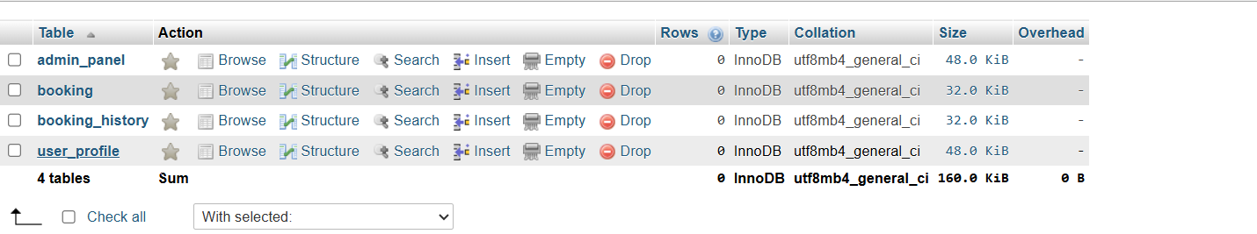

### Connection Php

<?php

$servername = "localhost";

$username = "root";

$password = "";

$dbname="library";

$conn = new mysqli($servername, $username, $password, $dbname);

if(!$conn){

die('Could not connect: '.mysqli_connect_error());

}

echo 'Connected successfully<br/>';

$u=$_POST["user"];

$p=$_POST["pass"];

$sql = "SELECT name,password FROM user where name= '{$u}' ";

$result = $conn->query($sql);

if ($result->num_rows > 0) {

while($row = $result->fetch_assoc()) {

if ($row["name"]== $u && $row["password"]==$p)

{

echo "You have been successfully Validated";

}

else

{

echo "Credentials Wrong, Try again";

}

}

}

else

{

echo "User name given was not exist";

}

$conn->close();

header("refresh:4; url=home.html");

?>

**8.Result**

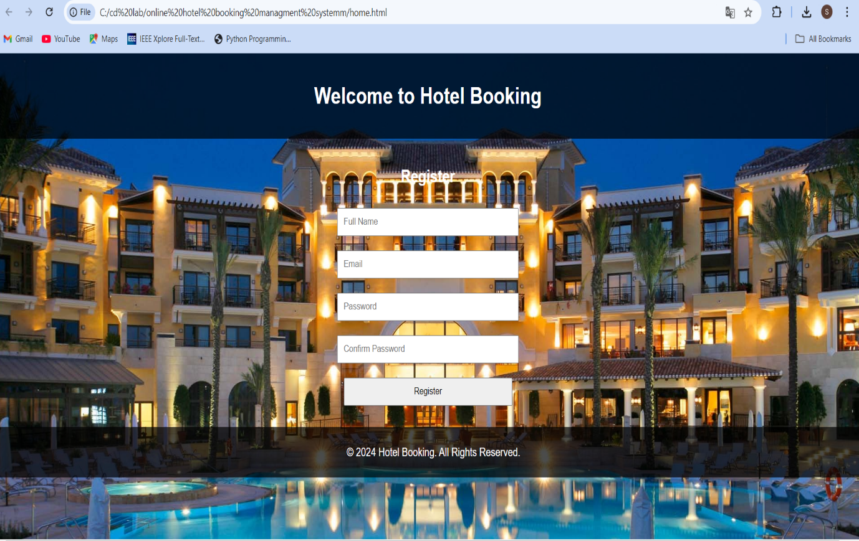

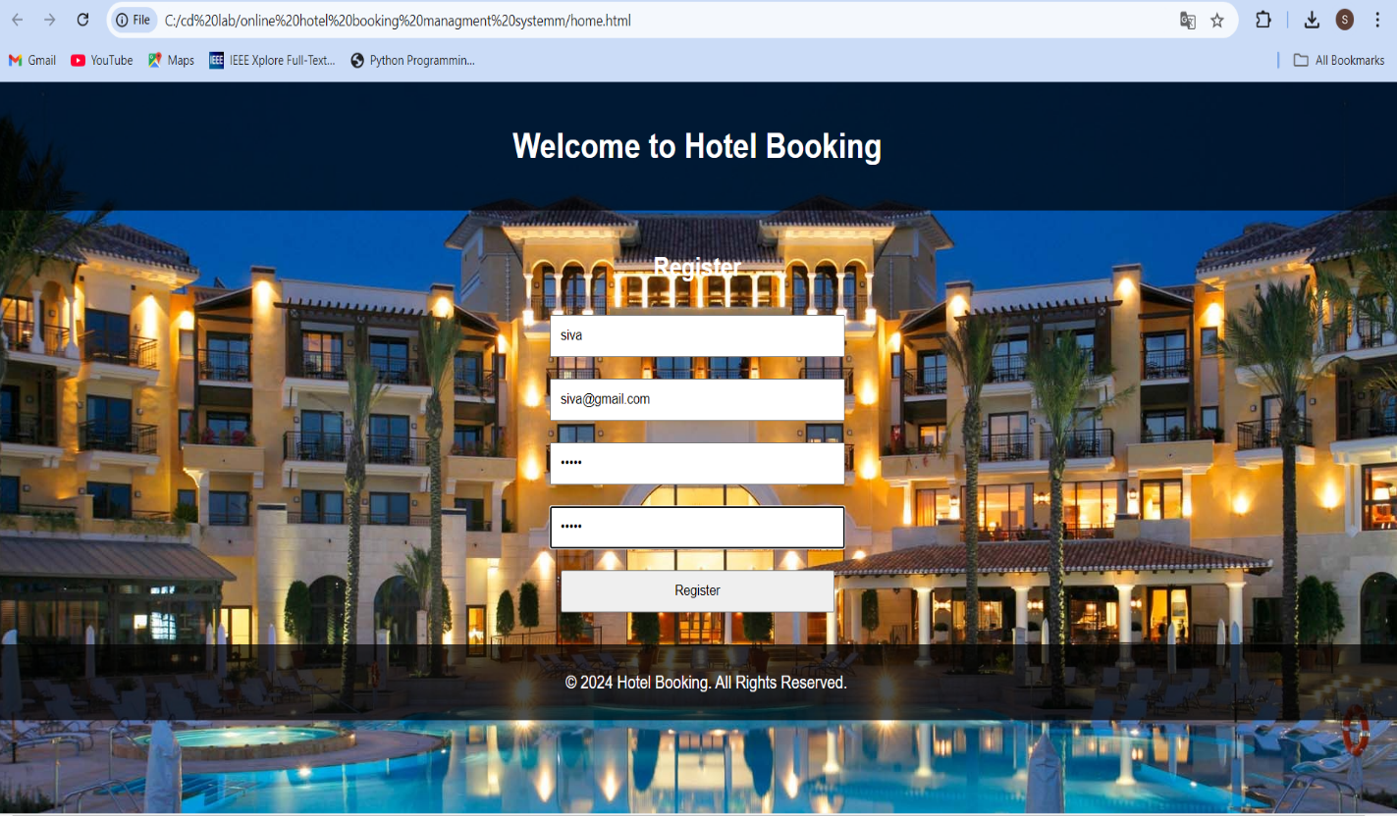

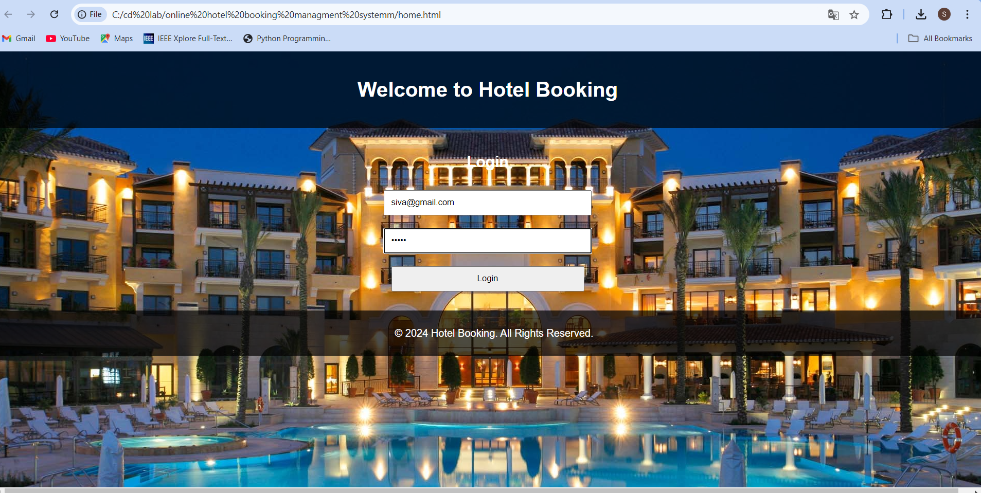

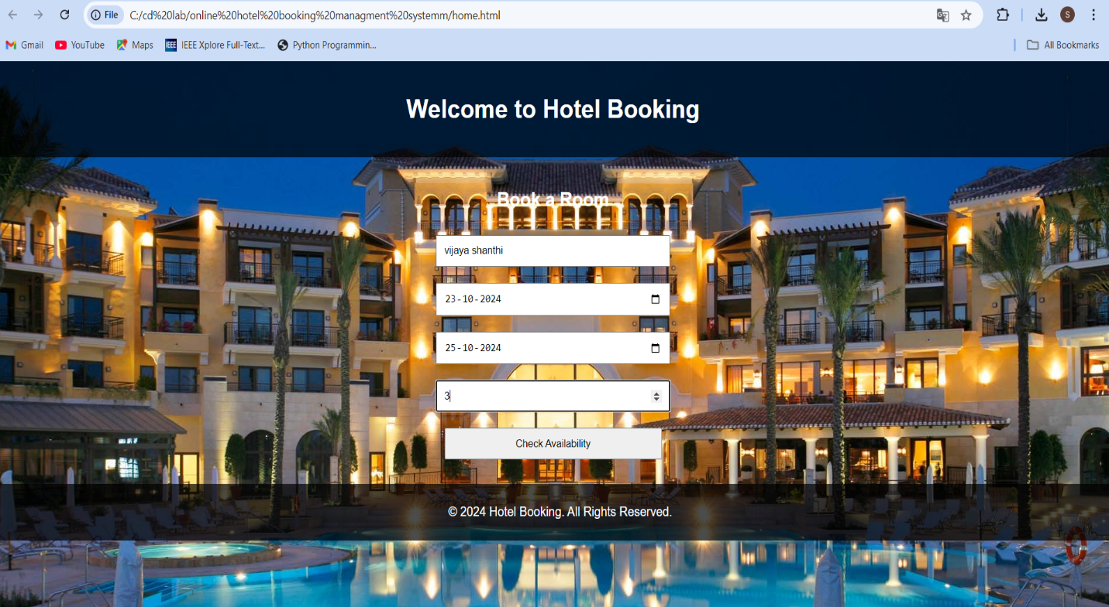

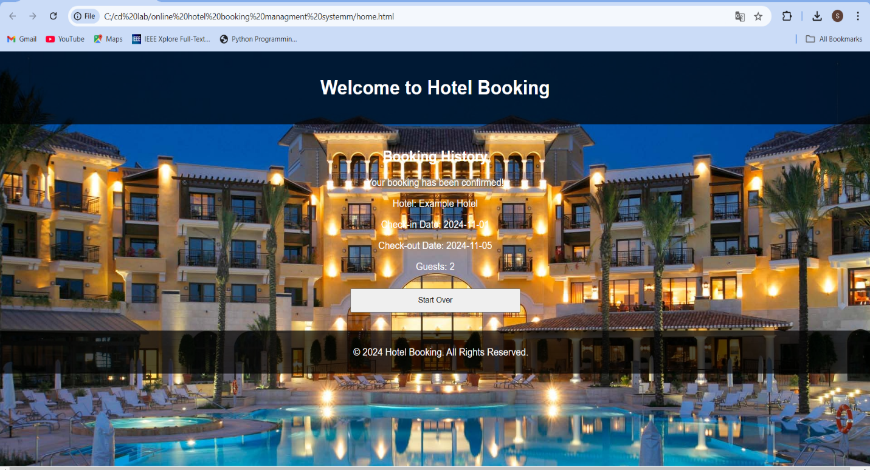

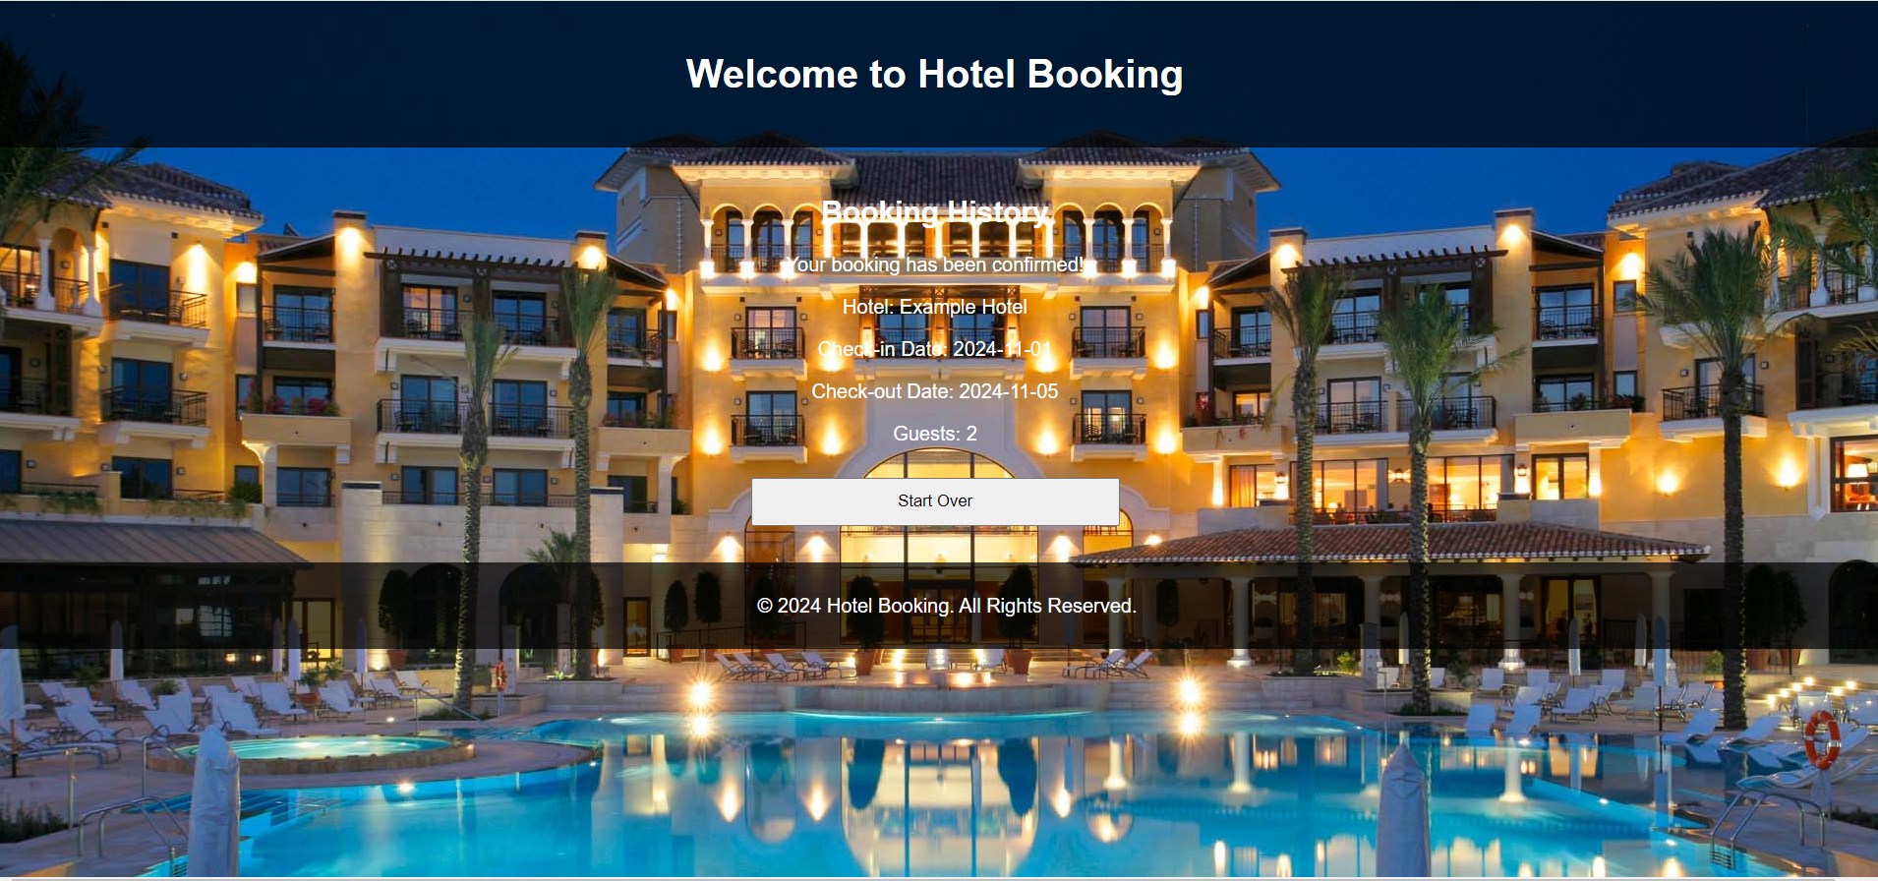

**9. Conclusion and Future Enhancements**

### An online hotel room booking system revolutionizes the way users search for and reserve hotel accommodations, offering a streamlined, user-friendly experience. By allowing customers to browse room availability, select dates, choose room types, and complete payments securely, the system provides convenience and flexibility. Additionally, users can manage their bookings, view history, and receive instant confirmation, reducing the need for manual coordination with hotel staff. This not only enhances user satisfaction but also allows them to book at any time and from any location, contributing to a more seamless travel experience.

### For hotel management, the system improves operational efficiency by automating booking processes, managing room inventory, and tracking customer preferences. Administrators can easily update room details, pricing, and availability, ensuring real-time accuracy. The integration of features such as booking cancellation policies and customer feedback further strengthens trust between hotels and their guests. Overall, an online hotel booking system benefits both the business and the consumer, making it an essential tool in the hospitality industry.

### References

1. Koulayev, S. (2009). Estimating demand in search markets: the case of online hotel bookings.
2. Chen, C., & Schwartz, Z. (2008). Room rate patterns and customers' propensity to book a hotel room. *Journal of Hospitality & Tourism Research*, *32*(3), 287-306.

1. Chen C, Schwartz Z. Room rate patterns and customers' propensity to book a hotel room. Journal of Hospitality & Tourism Research. 2008 Aug;32(3):287-306.
2. Lee, Z. H., & Cheng, K. (2009). Predictors of customer preference for online versus offline air travel booking. *Tourism Review International*, *13*(3), 183-200.
3. Lee ZH, Cheng K. Predictors of customer preference for online versus offline air travel booking. Tourism Review International. 2009 Dec 1;13(3):183-200.
4. Šimunić, Maja. "MODERN TRENDS IN RATE AND YIELD MANAGEMENT POLICIES WITH AN EMPHASIS ON WEB BOOKINGS." *Informatologia* 46, no. 2 (2013).
5. Carvell, Steven A., and Daniel C. Quan. "Low-price guarantees: How hotel companies can get it right." (2005).
6. Colangelo, Margherita, and Vincenzo Zeno-Zencovich. "Online platforms, competition rules and consumer protection in travel industry." *J. Eur. Consumer & Mkt. L.* 5 (2016): 75.
7. Föbker, Nina. *Can you resist?: The influence of limited-time scarcity and limited-supply scarcity on females and males in hotel booking apps*. MS thesis. University of Twente, 2018.
8. Cossa, R., & Tappata, M. (2013). Price Discrimination 2.0: Opaque Bookings in the Hotel Industry. *SSRN Electronic Journal*.